MAKING CHROMATOGRAPHY MORE ROBUST

Brian Rohrback Scott Ramos
President Chief Scientist
Infometrix, Inc. Infometrix, Inc.
11807 North Creek Parkway S 11807 North Creek Parkway S
Suite B-111 Suite B-111
Bothell, WA 98011 Bothell, WA 98011

KEYWORDS

Process Analysis, Gas Chromatography (GC), Chemometrics, Chromatographic Alignment, Simulated Distillation (SimDist), Detailed Hydrocarbon Analysis (DHA)

ABSTRACT

There are many process measurements that can be made to improve the monitoring, and ultimately control, of a chemical process. Deploying a chromatograph is critical to many complex streams in that it allows detailed information on the composition of nearly any mixture. Further, chromatography is relatively simple to calibrate and gives four or more orders of magnitude of linear-response in quantitating individual compounds of interest. With the advent of fast GC technologies, chromatography is being pressed into service to complement optical spectroscopy as a means of integrating better control strategies in the plant. However, there are issues that impact chromatography and add to its maintenance demands: sampling system problems; chromatographic component aging; and instrument-to-instrument variability that can frustrate direct comparison of one chromatograph’s output to another. Computer-enabled technology can be applied to mitigate the impact of aging and instrument differences which, in turn, leads to a more robust, lower maintenance world for process GCs. The key issue is to control retention time drift. This control needs to be implemented both on the hardware side of the system and on the software side. The software role in handling peak migration is discussed in this report with examples drawn from detailed hydrocarbon analysis (PINA, PIONA) and simulated distillation.

INTRODUCTION

Industry is in constant search for means to improve yield, lower costs, and automate manufacturing operations. Ultimately, any quest to generate production benefits is an attempt to improve the information derived from measurements of the raw inputs, the process itself, or the final products. This search invariably leads to change in how the process is managed. There are many measurements that can be made in any chemical process with the most common being pressure, temperature, flow, and level. However, there are only two types of measurement that are able to monitor the chemistry: spectroscopy and chromatography. These two instrumental technologies provide complementary information—spectrometers measure functional groups; chromatographs measure molecules.

Measuring chemistry is extremely important if the goal is to understand and better control the process. The balancing factor is the increase in effort (and cost) of calibrating and maintaining spectrometers and chromatographs on-line compared to, say, a temperature sensor. This paper describes a technology that can often simplify the cost of ownership by reducing the calibration effort; in some cases, a GC can be put in place without calibrating at all.

GAS CHROMATOGRAPHY

It is one thing to design features into an instrument system, but another to look at all the other aspects that have an impact on that system’s reliability when placed in use. A chromatograph, particularly in a process setting, must be able to perform consistently over a long period. Ideally, one would work to reduce the time required to keep that chromatograph operating at a consistent enough level to give the operators reliable and verifiable data to help monitor, even control the process. This becomes more critical as the frequency of chromatographic analysis increases to meet the control requirements for a fast reaction unit.

In the petroleum industry, the most information-rich process measurements come from gas chromatographs. The industry is looking to have access to more information in a more-timely way so that better control of the process is the norm. To eventually close this control loop, it is necessary to speed up the chromatographic analysis. Fast GC coupled with chemometric technologies enable some very innovative approaches to real-time modeling, prediction, and process state assessment. Automated alignment routines are critical to that vision.

Chromatography has suffered from several issues that have kept it from being integrated to full advantage in the process setting. One is to relegate the process chromatographs to only the simplest separations, figuring it best to process more complex chromatograms under the management of a control laboratory. Restricting the process applications to simpler samples means that the tool is not being fully utilized when faced with complex sample mixtures. Moving to capillary columns and lab-originated methods to manage the complexity can hamper the speed of analysis which in turn eliminates the possibility of using the chromatogram as a basis for real-time control in a process setting. Extending the thought makes practitioners think that the samples must be sent to a lab for the complex analyses, which guarantees that the data will only be used in a post-mortem role at best.
Migrating to the current generation of GCs, chromatographic analysis can be made faster to the point that it can be used to monitor or control a process in real time. Speeding the analysis will tend to cram more peaks into a shorter time frame. But because peak retention on the column has some variability, this increases the likelihood of misidentifying a peak and, ultimately, risks misreporting a component’s concentration. Chromatographic retention time drift from run to run is always present, but usually is not a significant source of variability. Over time, however, any retention drift amplifies the risk of an error in peak identification which can lead, in turn, to mistakes in peak tables (e.g., misidentification of components in DHA) or in evaluating the overall distribution (e.g., simulated distillation).

In prior papers (1, 2), Rechsteiner, et al., described a change in approach for handling gas chromatography on-line; this paper continues that theme by focusing on retention time drift and a generic solution to this problem. The result is the ability to handle process chromatographic data in a more robust manner.

CHEMOMETRICS

Chemometrics is a field that has seen much use in the management of optical spectroscopy data collected for monitoring a chemical process, and is routinely integrated into the analytical workflow both to improve the signal and to process the signature into useful quantitative and qualitative information. In signal processing, the goal of chemometrics is to minimize variation unrelated to chemical composition and to quantify properties or classify materials based on chemical characteristics.

Chromatography covers applications where hydrocarbon classifications and quantitative analysis can be done in industrial settings quickly and inexpensively. With some of the more recent engineering changes in column heating and cooling, process GC is fast enough to be able to make decisions in a time frame commensurate with optical spectroscopy. Because process data comes fast and furious, with little time to allow detailed evaluation of individual chromatograms, it becomes increasingly critical to manage retention time variability and make the data stream as consistent as possible. Addressing retention time variation simplifies ownership of a GC by making the data consistent from one month to the next, even one instrument to the next.

METHODS

Gas chromatographic data for the simulated distillation application was collected using Calidus gas chromatographs (Falcon Analytical Systems & Technology, Lewisburg, WV) running ChromPerfect software (Justice Laboratory Software, Denville, NJ). For detailed hydrocarbon analysis, the processing was performed on a 6890 GC operating ChemStation software (Agilent Technologies, Little Falls, DE). High Temperature SimDist results were acquired using Agilent’s EZChrom software. Retention time alignment was conducted by LineUp software (Infometrix, Inc., Bothell, WA). DHA and SimDist 2000 software (Envantage, Cleveland, OH) provided the computation and final reports. Chromatographic columns for the Calidus GC analysis were supplied by Restek (Bellefonte, PA).

RESULTS AND DISCUSSION

Chemometric alignment technology has been discussed in the ISA forum before. Figure 1 shows an example of the chromatographic quality improvement gained from aligning complex refinery chromatograms collected over a series of years (2). Although the instrument remained the same, there were several column changes creating method variations that impacted retention time consistency. The algorithmic mechanism for alignment here focuses on a multivariate correlation approach that is described in a following subsection. Figure 1 also shows, there are significant shifts that make it difficult to track the individual peak identities without a human-centered check; the algorithmic correction (3) successfully adjusts for retention time shift.

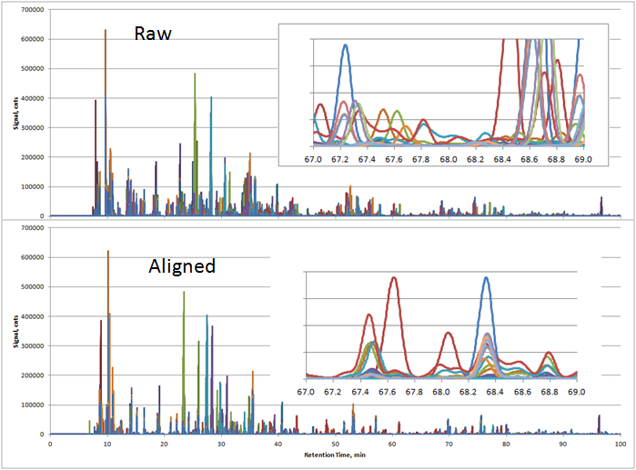

FIGURE 1. RAW AND ALIGNED GC ANALYSIS – RETENTION TIME ALIGNMENT LEAVES ONLY THE CHEMICAL COMPOSITION DIFFERENCES ON DISPLAY

Figure 1 demonstrates that, without alignment, the underlying chemistry is not easily characterized and the system is not conducive to automated analysis. Any misidentifications will result in a corresponding mistake in quantitation. Alignment technology minimizes the retention shift leading to more accurate peak identification and more reliable data.

METHODS OF CHROMATOGRAPHIC ALIGNMENT

An examination of the tools that exist for retention time alignment is warranted. All require having some sort of prior knowledge: a reference chromatogram to which we try to adjust new runs so that the time axes are consistent. Traditional mechanical or software solutions have been in use at various levels of sophistication for decades.

One approach is an interactive adjustment to the GC conditions (pressure and temperature programming) to iterate toward a consistent chromatogram. The notable example is electronic pressure control which is often used to mitigate changing environmental conditions (with judicious use of calibration or validation standards) and thereby move peak positions into historical placement. The problem here is that such a mechanical change cannot correct for any chromatogram that has already been run; it only looks to the future. Preventative maintenance is great, but not always achievable, particularly in the less-attended process installations. Even with well-tuned pressure control, some retention drift is still likely.

One can also adjust column conditions so that the peaks reliably show up within a prescribed time window and give responsibility to the peak table assembly process. Because, ultimately, the time window either must decide that it will choose the largest peak or else the peak closest to the midpoint of the window, this approach in turn represents another source of potential misidentification. Of course, changes in the integration procedure can be applied to historical data. This requires a technician’s input and, further, requires some knowledge of both the process chemistry and the science of chromatography.

There are tools for real-time or post run retention time adjustment that require little or no user involvement. These represent the best means of chromatographic retention time adjustment if it is to be performed in an automated manner either on-line or in the laboratory. The methods below are also able to accommodate additional components or missing components to some degree.

- The simplest means of handling retention time movement is to apply a linear shift. The procedure is to slide the newly acquired chromatogram against the standard chromatogram until the peaks align. This is successful if the difference in the retention times is driven primarily by inconsistent time gaps between sample injection and initiation of data collection. A shift correction can be automated by calculating a correlation coefficient between the target and the newly shifted chromatogram and comparing against all possible shifts; the highest correlation determines the magnitude of shift correction and improves peak alignment.
- Markers are a univariate alignment technology that has been in use since chromatography was first described. In the 1960s, this approach was formalized and brought into routine use by Kováts (4), who made use of the nearly ubiquitous presence of normal paraffins in hydrocarbon samples to establish a retention index (C₁₀ = 1000, C₁₁ = 1100, etc.), giving the opportunity to interpolate indices for all peaks falling between successive n-paraffins, thus allowing positioning of the intervening peaks. The assumption is usually made that drift between pairs of n-paraffins is linear, and to a first approximation that works. A complication comes when a sample is slightly overloaded in an on-column injection, causing the higher intensity peaks to go off scale or for their peak shapes to become increasingly asymmetrical, with concomitant shifts in their position relative to components in-between. Generic marker-based alignment using this concept of retention indices was formalized into an algorithm by Malmquist (5).
- Chemometric correlation is a multivariate approach that will adjust a chromatogram’s retention axis to more closely resemble that of a target. In the examples given in this paper, the technology in use is Correlation Optimized Warping (COW) and through this means, adjustments can be made for variations in column loading, column aging, and changes in flow. The technology was detailed in a paper by Nielsen et al. (3) and is described in brief in the section below.

It is important to note that the above three near-real-time methods can be used without oversight, bundled into a chromatographic method. Further, these three techniques can be used in combination during a single processing step.

CHEMOMETRIC CORRELATION

The COW algorithm works by dividing the chromatographic trace into a series of time segments. Each segment is approximately the width of an average chromatographic peak for that application. A target chromatogram must be chosen that represents a typical trace; the associated retention times of the target will be the times the algorithm will seek to match for all subsequent runs. The algorithm starts with the first of these small time segments at the end of the chromatogram to be aligned, stretching and shrinking the data to ultimately match the peak positions of the target. The correlation between the new trace and the target for the first segment is maximized. The algorithm then moves one segment width in from the end and repeats the stretch-shrink-comparisons until the second segment position offers the best correlation. This process continues across the entire chromatogram.

Even though software implementations allow multiple alignment techniques in combination, the authors chose to do the work in this paper exclusively with the COW algorithm.

CAUTIONARY NOTES

As with any analytical technique, there are sources of error unique to retention time adjustment that need to be considered. The first rule is to follow good chromatographic procedures regarding consistent methods, appropriate data acquisition rates, and column maintenance. The biggest sources of error come from not collecting enough points across the peak (data acquisition rate is too low), causing significant asymmetry in the peak shape, making it hard to match without altering the shape and ultimately the area of the aligned peak. In addition, large shifts in retention time can result in significant change in area following alignment. Look for the problem of inconsistent shifts by observing if the separation distance among peaks fluctuates in different parts of the chromatogram; this suggests that some peaks are not being handled well by the column material used.

Application: Detailed Hydrocarbon Analysis

One high-value application, where a full understanding of composition is important, is detailed hydrocarbon analysis (6). In this quantitative evaluation, the chromatography requires sufficient resolution to separate essentially all of the roughly 1,000 compounds that can be found in gasoline. Retention time drift is the nemesis, causing inopportune misidentification of peaks in the chromatogram. This, in turn, causes the report generated by the system software to inaccurately represent the product. Chemometric alignment provides unattended validation that the analyzer is running properly, the process is in steady-state, and guarantees that the table of results is an accurate reflection of the analysis.

As always, the first goal is to strive for absolute consistency in methods, columns, flow conditions and other variable parameters. Alignment can mitigate experimental changes: that columns will age over time, columns will get replaced, ambient air temperatures will change daily and seasonally, more than one instrument may be used for the analysis, the people and management structures in place can change.

TABLE I. RESULTS FROM TWENTY RANDOMLY SELECTED GASOLINE DHA RUNS SPANNING A SIX-MONTH PERIOD, VALUES IN MINUTES

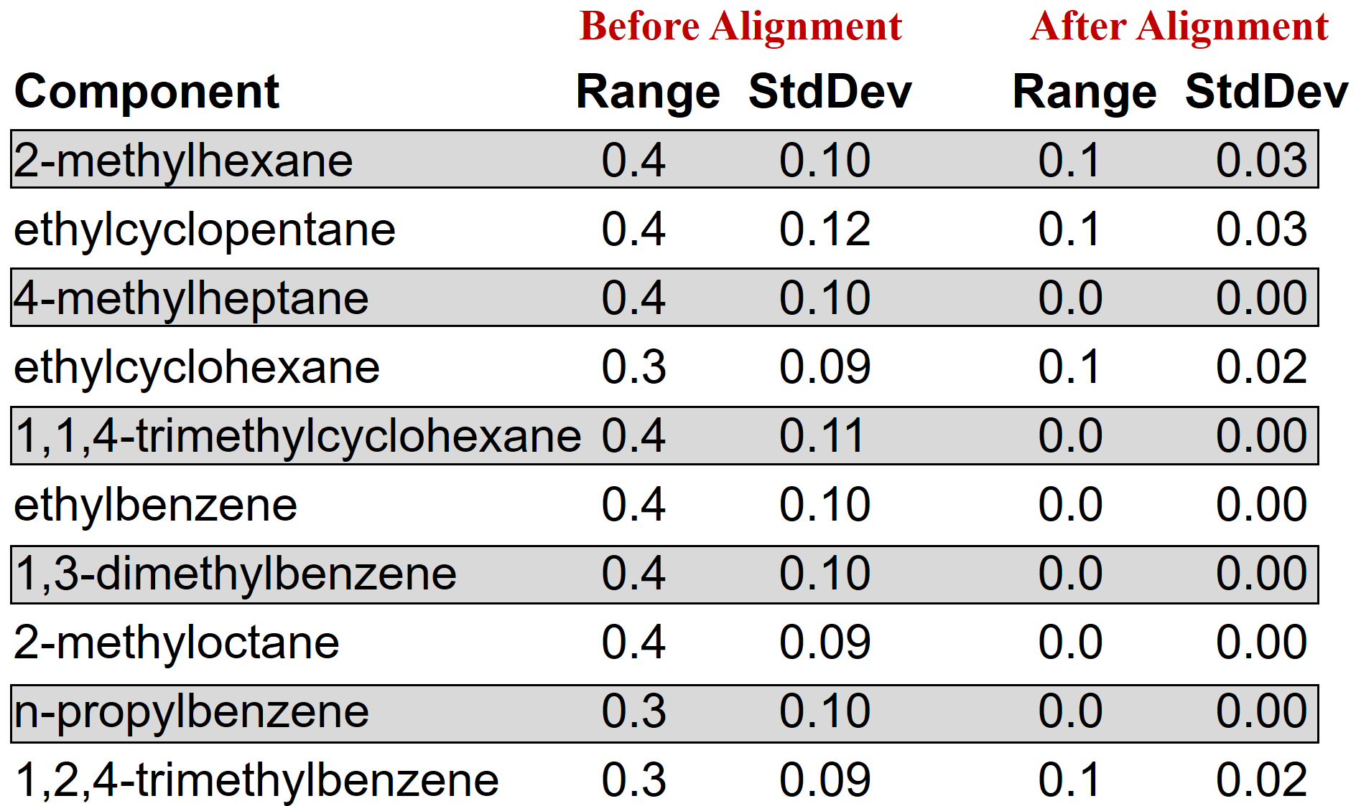

Table I shows partial results from a comparison made nearly 20 years ago, where twenty DHA GC runs were made, then aligned to an earlier gasoline chromatogram. Because the procedure requires very tight control on the retention times, there is little variability in the peak positions; even the unaligned chromatograms only vary within a 30 second window, here in a run of more than 2 hours. Even with small changes, peak misidentification is possible for closely-eluting peak combinations. After chemometric alignment, however, the variance in retention times essentially disappeared.

This test made it clear that automated alignment technology can be integrated into routine chromatographic methods and will make a difference even in instances where many peaks are involved. It also demonstrates the persistence of the approach over a multi-year period. Diagnostics (not shown) are available to identify when the data processing did not succeed and when recalibration is needed. In this way, alignment facilitates the performance of reliable DHA chromatography, with limited supervision.

Application: Simulated Distillation

In yield profiling, the concern is more with broader properties of the crude oil or fuel fractions than with the identification of individual components. Arguably, the most important of these yield applications is the evaluation of the distillation profile. Gas chromatography is a very attractive means of evaluating the distillation, as the analysis can be completed in minutes: for gasoline, often less than five minutes. This compares favorably to the 1+ hour cycle time required for a full-scale lab distillation. Using an instrument in place of the distillation column raises a question. Does the chromatographic separation process model the true distillation profile closely enough to allow its use as a surrogate? If chromatography does not cause a problem in analytical precision, then the GC results can give us a faster, more detailed level of understanding of the yield curve.

In common use, the SimDist procedure starts with running an n-paraffin standard to establish the retention time that corresponds to each compound. Because the boiling point of every n-paraffin in known, boiling points can be assigned to positions in chromatographic time. A reference gas oil (RGO) that has a well-characterized SimDist trace is then run. If the result on the recent RGO run matches expectations within the limits set by ASTM procedures, unknown samples can be processed. The earlier n-paraffin run’s map then forms the basis of the translation of the sample chromatogram into a yield (or boiling point) curve.

Figure 2 shows an overlay of the same sample run many times in a 3-year period. It is clear that the retention times of peaks move; the traditional way of handling this situation is to rerun the standard and accept new time positions for the n-paraffin peaks. This gives a very short-term context and, by causing frequent recalibrations, lowers the number of samples that can be processed. Hands-on recalibration makes the system more unreliable on-line, where it is harder to attend to these changes. This relegates simulated distillation quite often to a supervised lab, rather than placing it in a shelter near the sampling point, where the feedback would be timely.

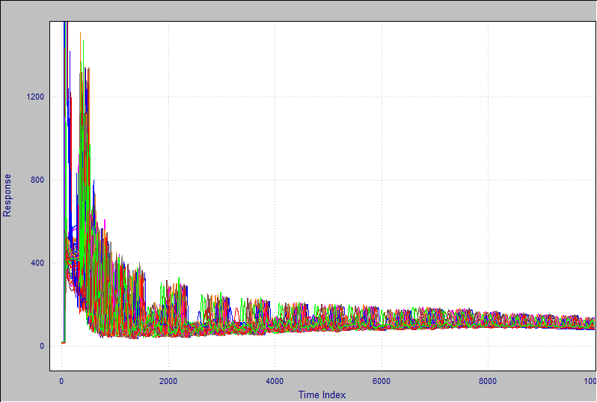

FIGURE 2. HIGH TEMPERATURE SIMULATED DISTILLATION CHROMATOGRAMS SPANNING 2014 TO 2016 – ALL LABORATORY RUNS

But what if the retention time did not change? This is an example of where chemometric alignment technology should be used.

For chemometric alignment to work, one chromatogram must be chosen to be the alignment standard; alignment then adjusts the peak positions in all the other traces to match that standard as closely as possible. The results of this process are seen in Figure 3. After alignment and compared to Figure 2, we can easily see that consistent peak retention time is achieved.

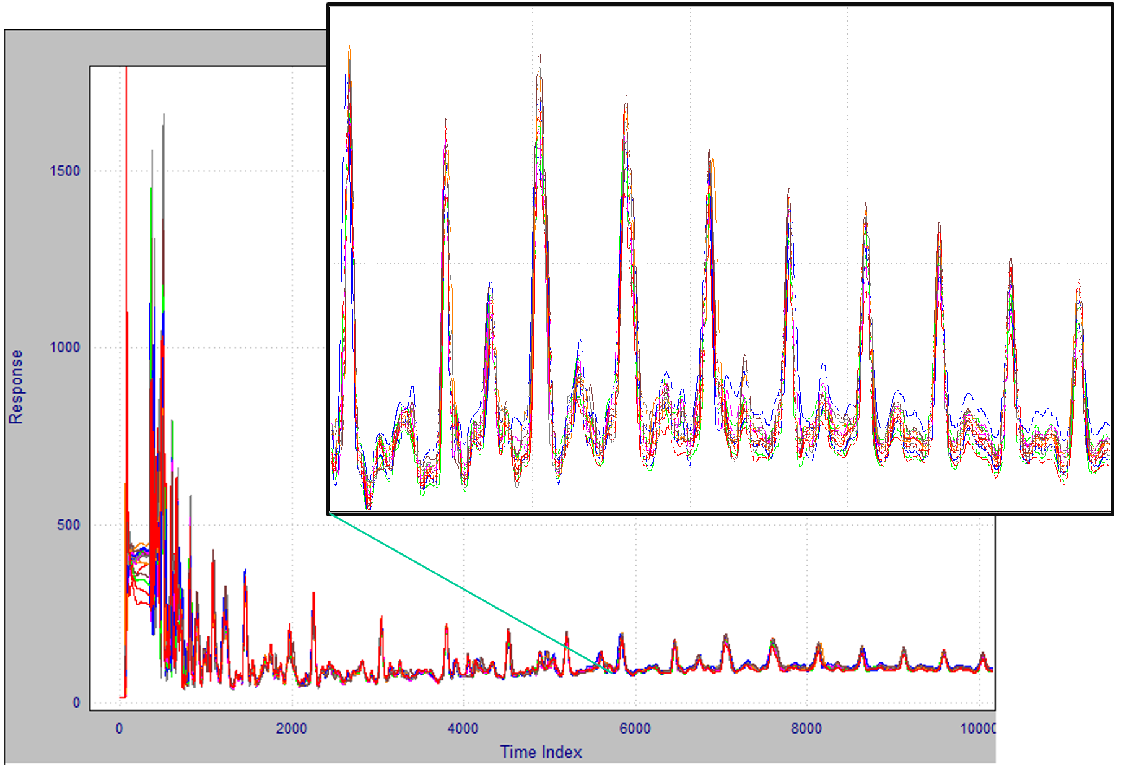

FIGURE 3. THE RESULT OF CHEMOMETRIC ALIGNMENT ON HIGH TEMPERATURE SIMDIST CHROMATOGRAMS – EXAMPLES FROM 2014

Note that the COW-based alignment did not make use of the n-paraffin standard at all. Because each of these chromatograms were originally run on separate days, they all had different n-paraffin standards run prior to their analysis. With this correlation-based alignment, only one n-paraffin standard was relevant to the analysis: the one that preceded the injection of the alignment target chromatogram above.

What this suggests is that the procedure of running the n-paraffin standard daily is not necessary unless there is a very significant change in method or column. If alignment is properly used, there is no need to run the paraffin standard, certainly no need to run it frequently. But the chromatograms shown in the above experiment were just re-runs of the same sample.

In 2014, the ASTM organized an inter-laboratory study to qualify a fast simulated distillation procedure (ASTM 7798). For this effort, a series of refinery fractions were prepared and subsets sent to different laboratories. Figure 4 shows a zoomed-in section after alignment for one participating lab. In contrast to the example shown in Figure 3, all these samples were of different fractions. Still, the alignment works extremely well. In this case the alignment target was the reference gas oil.

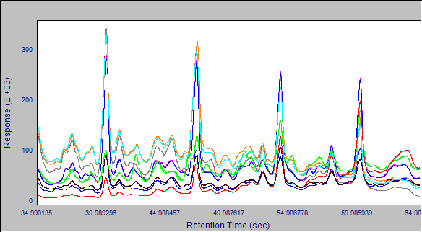

FIGURE 4. ALIGNMENT OF DIFFERENT TEST SAMPLES TO THE REFERENCE GAS OIL: GC#1 DATA ALIGNED TO GC#1’S RGO SAMPLE

In the case presented in Figure 4, the alignment target RGO was run on the same instrument as the sample runs. What if the alignment target chromatogram run on this instrument was used to correct the retention times of samples run on a second instrument in a different location? This test is shown in Figure 5 below.

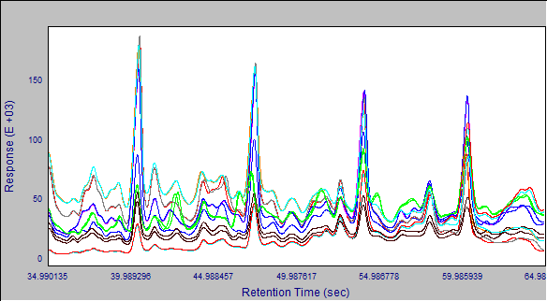

FIGURE 5. ALIGNMENT OF DIFFERENT TEST SAMPLES TO THE REFERENCE GAS OIL: GC#2 DATA ALIGNED TO GC#1’S RGO SAMPLE

It is clear from the zoomed view in Figure 5 that the retention times from one instrument can be aligned to a reference target chromatogram run on a different instrument. In this case, there is advantage in that the instrument methods and columns were close to identical.

Regardless of whether we adjust to a chromatogram collected on the same or a different instrument, the chromatograms look to be in nearly perfect alignment. Now the question shifts to the impact on the final SimDist results. A view of this is given in Figure 6. The retention time standard RGO from the first laboratory is used as the alignment target and ultimately the basis for the assigning of temperature values to time points.

FIGURE 6. THE IMPACT OF ALIGNING A CHROMATOGRAPHIC TRACE TO A STANDARD RUN ON A COMPLETELY DIFFERENT INSTRUMENT

In this example, the run from GC#2 is to be compared to the RGO standard from GC#1. Both the unaligned and the aligned traces were processed for SimDist results and the differences in temperature at every point again were compiled. Figure 6 shows these results with the top line displaying the unaligned results and the bottom line indicating deviation from the expected value for the processed aligned chromatogram.

As expected, without alignment, the chromatogram processed on GC#2 shows a significant bias compared to the RGO standard run on a different GC. In the case shown, the values range between 5-degrees and 7-degrees away from what they should be. The completely-automated aligning of that same data shifts the retention times to be compatible with GC#1, and the SimDist results match the expected values very closely, averaging +/- 0.5 degrees F and all are within 1.3 degrees F across the boiling point range (the lower trace of Figure 6).

Figure 6 shows the value of chemometric alignment in simulated distillation. Although the graph represents the data for only a single run, the same behavior was seen for every replicate of every run, of every sample type, on every instrument in this inter-laboratory study. These results demonstrate that it is possible to correct retention times to match an application-specific relevant sample and make all instruments performing a similar task look identical. This approach also raises the possibility of having a universal calibration if the chromatographs used are reasonably consistent in method and hardware.

CONCLUSIONS

The power of using a software-based alignment tool has been demonstrated for two application cases. In the case of detailed hydrocarbon analysis, alignment keeps the peaks in place for a significantly longer time and reduces the manpower necessary to keep the system calibrated. In the simulated distillation example, multiple instruments can run the same method even though slight differences in column and flow conditions make chromatograms not match the time axis from instrument to instrument. Normally, this would require separate calibrations or even slightly separate methods for each instrument. With chemometric alignment, these minor variations can be compensated for and identical methods be used, potentially even skipping the calibration step. At the least, the frequency with which an operator needs to run calibration standards is significantly lower that what is currently being done.

The idea is very powerful: that a small amount of software can be added to a chromatograph and have that addition open a true Plug-and-Play capability for the instrument/application. Ostensibly, a company could keep a cold spare chromatograph in inventory. When a process or lab unit goes down for any reason, the storage unit would be placed on-line and have its data be completely comparable to all previous runs on its very first injection, possibly without ever running a calibration step. Alignment can also apply this procedure to the historical chromatographic data assembly, giving a consistent database ready to be mined.

Of course, this conclusion holds for situations where the column and the method conditions are very similar. But if this is the case, it may be possible to think of a chromatograph with the same supply and repair mindset more often reserved for temperature and flow sensors. Application-specific chemistry knowledge is easier to set up and more reliable in operation.

ACKNOWLEDGEMENTS

As always, work that goes into a paper like this is not the sole purview of the listed authors. Many people assisted with data collection and connection to process users in several countries. The authors’ thanks go in particular to the following exceptionally talented and insightful people:

- Tom Grills, Envantage
- Rajko Puzic, ExxonMobil
- Aosheng Wang, Siemens Industry
- Robert Lorenz and Carl Rechsteiner, Jr., Chevron ETC
- John Crandall and Joseph Perron, Falcon Instruments
- Don Crider and Eef Klok, AC Analytical Controls
- Marlana Blackburn, Infometrix
- The ASTM 7798 ILS Laboratories

REFERENCES

1. Crandall, J., Rohrback, B. and Rechsteiner, C., “Towards a More Robust Process GC”,
Proceedings of the Instrument Society of America Meeting, Analysis Division, April 21, 2008, Calgary, Alberta, Canada.

2, Rechsteiner, C., Carlson, M., Crandall, J., Roques, N., Bostic, S. and Rohrback, B. “Rethinking, then Re-Engineering Gas Chromatography”, Proceedings of the Instrument Society of America Meeting, Analysis Division, April 18, 2011, League City, Texas.

3. Nielsen, N-P. V., J. M. Carstensen and J. Smedsgaard, “Aligning of Single and Multiple
Wavelength Chromatographic Profiles for Chemometric Data Analysis using Correlation
Optimised Warping”, J. Chromatogr. A, Vol. 805, 1998, pp.17-35.

4. Kováts, E., Adv. Chromatogr., 1: 229 (1965).
5. Malmquist, G. and R. Danielsson (1994). "Alignment of chromatographic profiles for principal component analysis: a prerequisite for fingerprinting methods", J. Chromatogr. A, Vol. 687, 1994, pp.71-88.
6. Teng, S.T., Williams, A.D. and Urdal, K., “Detailed Hydrocarbon Analysis of Gasoline by GC-MS (SI-PIONA)”, J. High Res. Chromatogr., Vol. 17 (6), 1994, pp.469-475.

